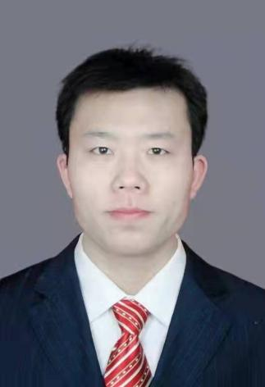
Cui Guochao
Associate Professor
- sc Supervisor
Innovation Team of Cultivation Physiology and Techniques of Drupe Fruit Trees, ZFRI, CAAS

Contact
Email: cuiguochao@caas.cn

Research interests
Popularization of peach cultivation techniques

