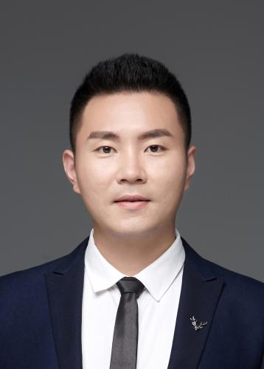
Huang Zhenyu
Associate Professor
- sc Supervisor
Innovation Team of Cultivation Physiology and Techniques of Drupe Fruit Trees, ZFRI, CAAS

Contact
Email: huangzhenyu@caas.cn

Research interests
Germplasm resources innovation and molecular breeding of plum and apricot

