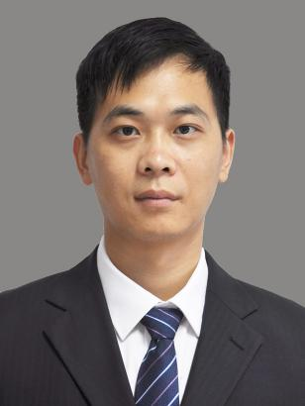
Zeng Wenfang
Professor
Ph.D. Supervisor
Innovation Team of Cultivation Physiology and Techniques of Drupe Fruit Trees, ZFRI, CAAS

Contact
Email: zengwenfang@caas.cn

Research interests
Fruit developmental mechanism and molecular breeding of peach

