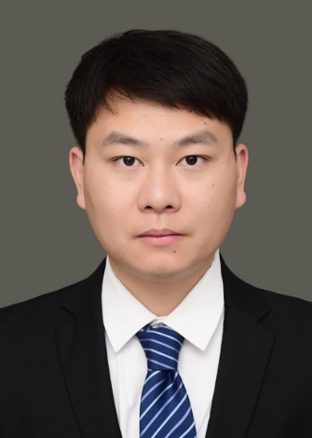
Sun Shihang
Assistant Professor
Innovation Team of Cultivation Physiology and Techniques of Drupe Fruit Trees, ZFRI, CAAS

Contact
Email: sunshihang@caas.cn

Research Interests
Molecular mechanism of peach rootstock resistance

