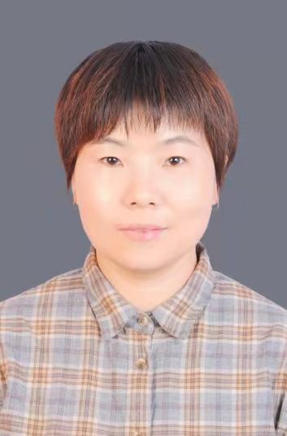
Liu Li
Associate Professor
- sc Supervisor
Innovation Team of Cultivation Physiology and Techniques of Drupe Fruit Trees, ZFRI, CAAS

Contact
Email: liuli@caas.cn

Research Interests
Simplified and efficient cultivation model study

