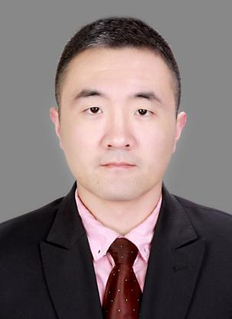
Si Peng
Associate Professor
- sc Supervisor
Innovation Team of Cultivation Physiology and Techniques of Drupe Fruit Trees, ZFRI, CAAS

Contact
Email: sipeng@caas.cn

Research interests
Research and application of fruit tree nutrient management model

