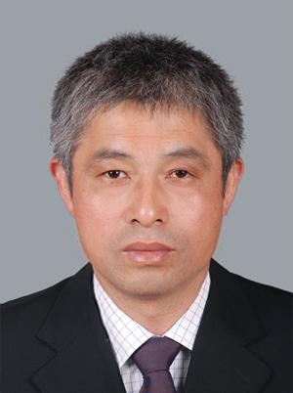

Liu Chonghuai
Professor
Ph.D. Supervisor
Innovation Team of Grape Genetic Resources and Breeding. ZFRI.CAAS

Contact
- Email:liuchonghuai@caas.cn
- Tel:86-371-65330966
- Add:
Zhengzhu fruit research insititute ,Hanghai Donglu, Guancheng District, Zhengzhou,Henan,China

Research Interests
Grape Resources Collection and Preservation
Grape Beeding
Grape Cultivation Technology

Selected Publications

Endophytic bacterium pseudomonas fluorescens RG11 may transform tryptophan to melatonin and promote endogenous melatonin levels in the roots of four grape cultivars
Frontiers in Plant Science
2017|Journal Article
DOI:10.3389/fpls.2016.02068

Integrating Omics and Alternative Splicing Reveals Insights into Grape Response to High Temperature endogenous melatonin in their hosts.
Plant Physiology
2017|Journal Article
DOI:10.1104/pp.16.01305

Genome Assembly and Transcriptome Analysis of the Fungus Coniella diplodiella During Infection on Grapevine (Vitis vinifera L.)
Frontier in microbiology
2020|Journal Article
DOI:10.3389/fmicb.2020.599150

New quantitative trait locus (QTLs) and candidate genes associated with the grape berry color trait identified based on a high-density genetic map
BMC Plant Biology
2020|Journal Article
DOI: 10.1186/s12870-020-02517-x

Transcriptome analysis reveal the putative genes involved in light-induced anthocyanin accumulation in grape ‘Red Globe’ (V. vinifera L.)
Gene
2020| Journal Article
DOI: 10.1016/j.gene.2019.144284

Events
no

