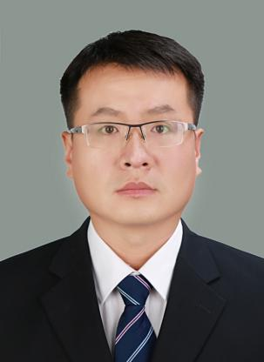
Pan Lei
Associate Professor
- sc Supervisor
Innovation Team of Cultivation Physiology and Techniques of Drupe Fruit Trees, ZFRI, CAAS

Contact
Email: panley@126.com

Research interests
Resistance breeding and cultivation physiology of peach

