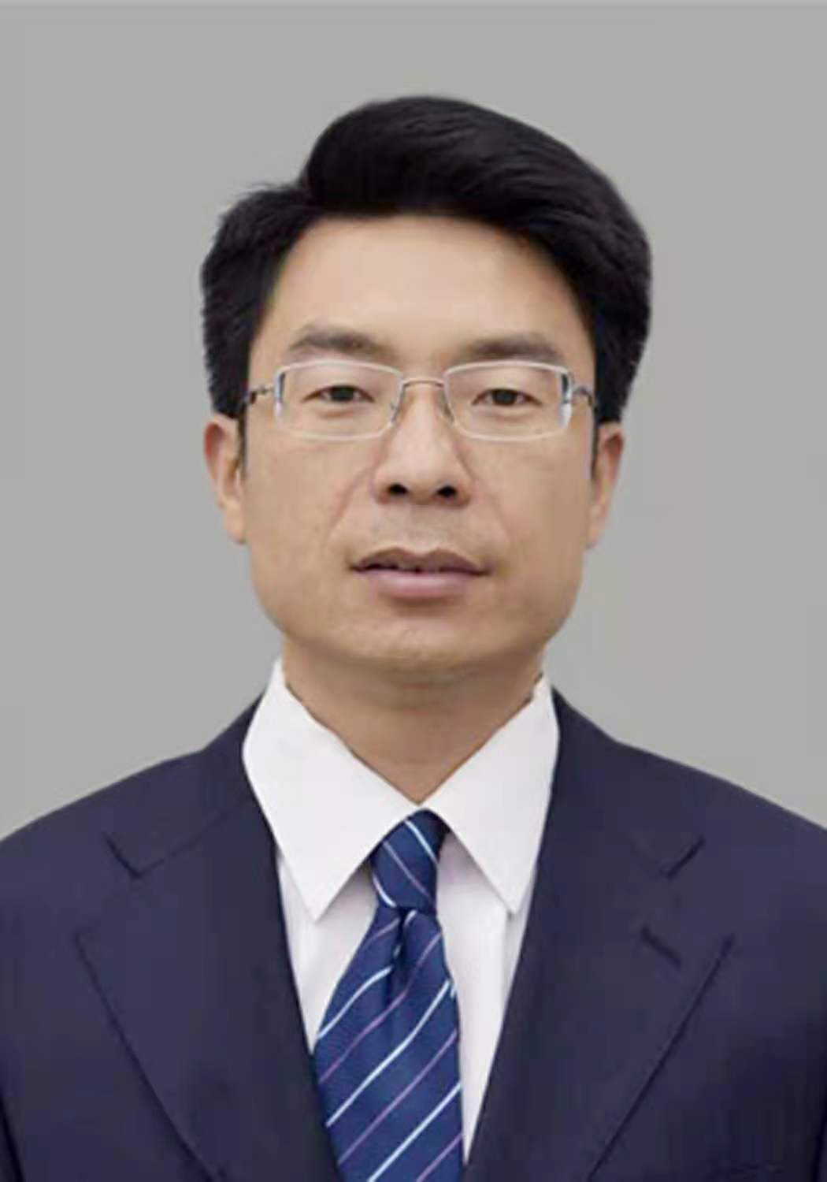
Gao Dengtao
Associate Professor
- sc Supervisor
Innovation Team of Cultivation Physiology and Techniques of Drupe Fruit Trees, ZFRI, CAAS

Contact
Email: gaodengtao@caas.cn

Research interests
Simplified and efficient cultivation model study

