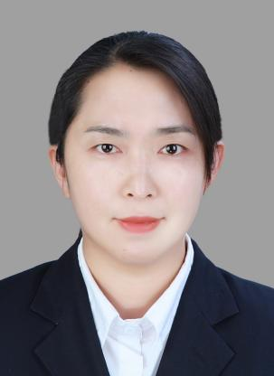
Liu Congli
Associate Professor
- sc Supervisor
Innovation Team of Cultivation Physiology and Techniques of Drupe Fruit Trees, ZFRI, CAAS

Contact
Email: liucongli@caas.cn

Research interests
Germplasm and breeding of cherry

